Monty Alexander – The Music of Frank Sinatra and Nat King Cole (for Downbeat.com)

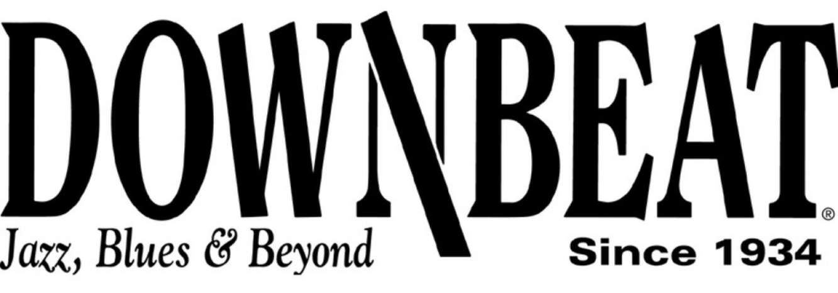
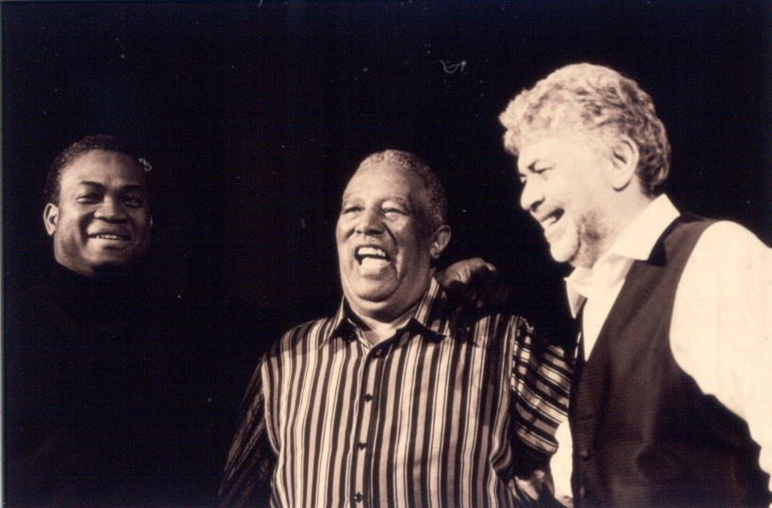

Monty Alexander – The Music of Frank Sinatra and Nat King Cole
(with Russell Malone, guitar, and Houston Person, tenor sax)
at Jazz at Lincoln Center, Dec. 9, 2011
By Allen Morrison

It was a classic New York evening at Jilly’s, the legendary bar owned by Sinatra pal Jilly Rizzo. The place was hopping, and the drinks were flowing. A blow-up of the club’s famous business card, suspended from the ceiling, contained the hand-written inscription, “My favorite bistro – Frank Sinatra.”

Except it wasn’t Jilly’s in the 1960’s, it was Jazz at Lincoln Center’s spectacular Allen Room, a jewel box of an amphitheater perched five stories over Manhattan’s Columbus Circle. The stage had been cleverly set to evoke the fabled NYC night spot, complete with tables, candles and drinks; in the back, a gleaming oak bar seemed to be fairly well-stocked, if only for show. Behind it all, Central Park and the New York skyline twinkled behind a five-story window wall.

The stage thus set, Monty Alexander, Jilly’s house pianist from 1963-1967, wandered in from the wings, playing “Mona Lisa” on his melodica. On his way to the Steinway concert grand, Alexander paused to address the 400-plus in attendance: “Ladies and Gentlemen, welcome to Jilly’s.”

The evening, the first of four sold-out shows, was an homage to his idols, Nat King Cole and Frank Sinatra, each of whom played a major role in establishing Alexander’s career as a jazz piano dynamo. Jilly’s, a hangout for the Rat Pack, as well as musicians, serious drinkers and gangsters, was where Alexander’s career kicked into high gear after Sinatra and Rizzo discovered him playing in Miami Beach and eventually flew him to New York.
Looking far younger than his 67 years, Alexander still has the goods. With his impish, goateed face framed by a mop of salt-and-pepper hair and his lilting Jamaican patois, he charmed the crowd, then proceeded to wow them with technical prowess and youthful exuberance.

Alexander explained the Cole connection, saying that as a 10-year-old in Jamaica he adored his parents’ Nat King Cole records. “Then Nat came to do a show in Jamaica, and my parents took me to see him. That’s when I decided I’m not gonna work for a living – I’m going to play the piano!”

He then proceeded to play the stuffing out of it, backed by the virtuosic trio of Hassan Shakur on bass, Dennis Mackrel on drums (on loan from the Count Basie Orchestra, which he leads), and Bobby Thomas, Jr. on hand drums and assorted percussion. Launching into Cole’s “Nature Boy,” he shepherded the quartet through a gentle Afro-Cuban groove into something decidedly more funky, and eventually into bop territory, while imaginatively reharmonizing the melody.

The group was then joined by the great Russell Malone on guitar – a veteran of several King Cole Trio-like configurations of piano, guitar and bass; the suave and masterful Houston Person on tenor; and two vocalists, the 23-year-old James DeFrances and veteran Allan Harris, who nicely evoked the great singers without trying to imitate, which would have been a dubious undertaking in any event.

The concert was more interpretation than tribute. While the legendary King Cole Trio swung deeply in its highly refined way, maintaining a poise and an essential gentility at all times, Alexander would not, perhaps could not, be constrained – he was intensely swinging, percussive, marvelously inventive – the full Monty.

Acknowledging the difficulty of choosing only 75 minutes worth of songs from the vast repertoire of Cole and Sinatra, Monty nevertheless chose wisely, capturing Nat’s essence in such songs as the relaxed and swinging “L-O-V-E,” “Sweet Lorraine,” and “Walkin’ My Baby Back Home;” and Sinatra’s in such gems as “Come Fly With Me,” “Angel Eyes” and “In the Wee Small Hours.” Given a chance to play solo, Malone thrilled with a breathtaking, finger-picked instrumental of a Cole signature song, “A Nightingale Sang in Berkeley Square.”
“Non Dimenticar,” Nat’s Italian hit, was lovingly recreated, with Alexander’s lovely wife, singer Caterina Zapponi, helping Allan Harris on vocals. On the tune, Monty reprised the lovely, lilting Nat-like piano part that he played behind Natalie Cole on her best-selling tribute album to her father, “Unforgettable: With Love.”

Monty has always been generous in allotting time to his brilliant sidemen. Nevertheless, he stole the spotlight throughout the evening without even trying, with intensely rhythmic clusters and breakneck runs, his great talent for reharmonization, and a seemingly inexhaustible supply of musical quotations covering the gamut from Brahms, to Ahmad Jamal, to “Santa Claus is Coming to Town.”

The New Yorker jazz critic Whitney Balliett famously once described the late Dave McKenna as “the hardest-swinging jazz pianist of all time.” Well, Dave’s gone now, and so are Oscar Peterson and Art Tatum, but Monty Alexander is still alive and kicking, and a worthy contender for the title.

